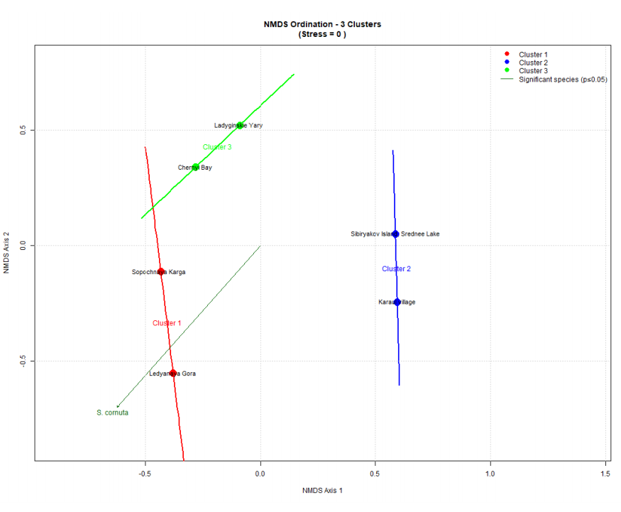

Figure 2: NMDS 3 Clusters
From the above figure we can see that:
Cluster 1 (red): Sopochnaya Karga and Ledyanaya Gora.
Cluster 2 (blue): Sibiryakov Island–Srednee Lake and Kara Village.
Cluster 3 (green): Ladyginskie Yary and Chernyi Bay.
According to this pattern, Ladyginskie Yary and Chernyi Bay have enough different community compositions to stand apart from the other red sites and establish their own cluster. S. cornuta's main species vector still points to the lower-left, indicating that it is associated with sites in that direction. Once more, a stress value of 0 means that the ordination accurately depicts the links between community similarity.

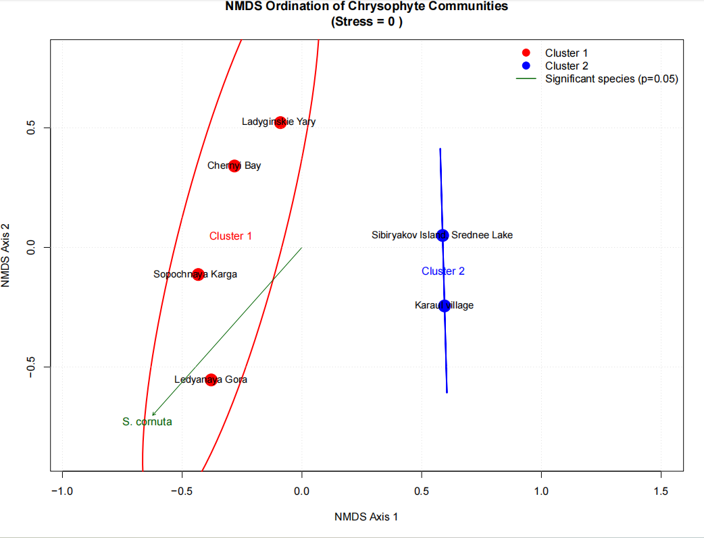
Figure 1: NMDS 2 Clusters
From the above figure we can see that:
Cluster 1 (red): Ladyginskie Yary, Chernyi Bay, Sopochnaya Karga, and Ledyanaya Gora.
Cluster 2 (blue): Sibiryakov Island–Srednee Lake and Kara Village.
Chrysophyte communities in Cluster 1 differ significantly from those in Cluster 2, as seen by the distinct split along NMDS Axis 1. The Synura cornuta (S. cornuta) black vector suggests that this species is a significant contributor to the between-site variations. Lastly, an excellent ordination fit is shown by a stress value of 0, which indicates that the plot accurately depicts the relationships between samples.

